Run FeeReport class
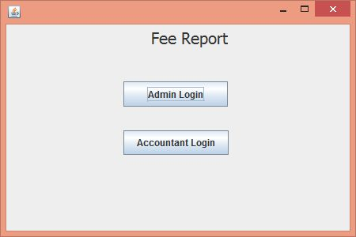
Click on Admin Login
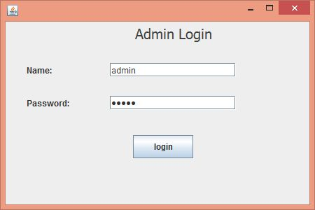
Name is: admin
Password is: admin123
click on login button, it will open Admin Section

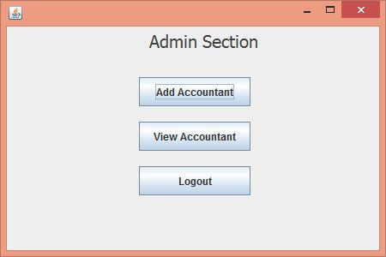
Click on Add Accountant
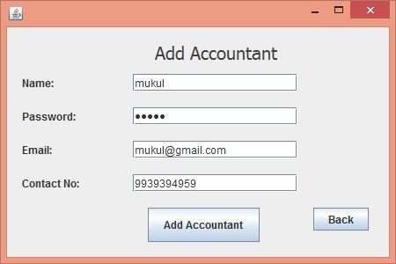
After adding accountant, click on back button.
Now click on View Accountant.
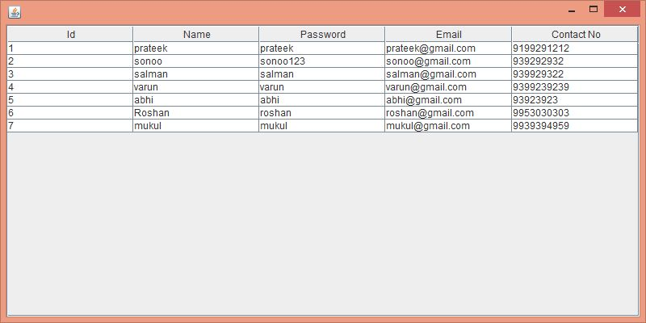
Now click on logout
Click on Accountant Login
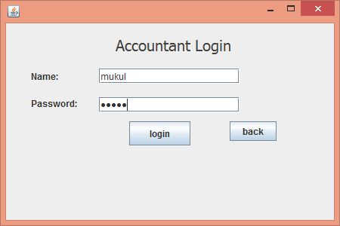
Use the name and password which you stored in database.
Click on login button.
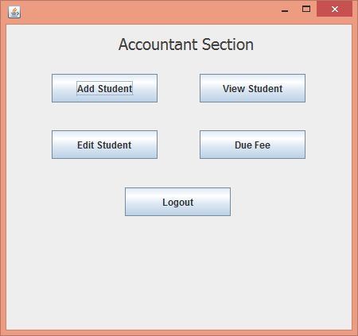
Click on Add Student
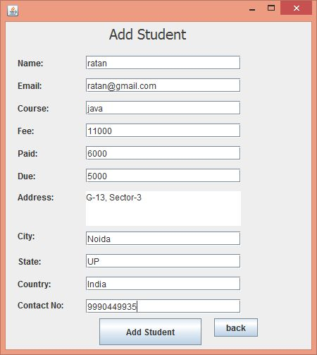
Fill information and click on Add Student
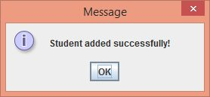
Click on ok. Now View Student.

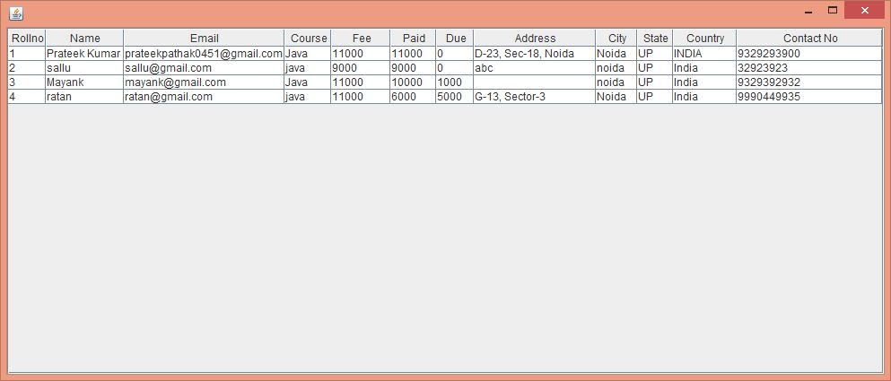

Now, click on edit button.
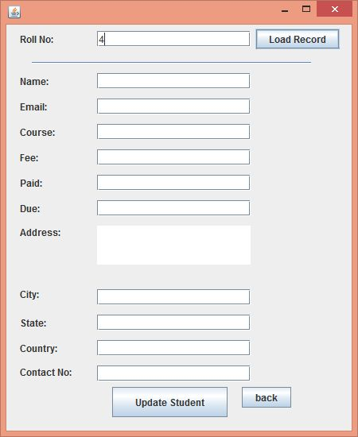
Enter rollno and click on load record.
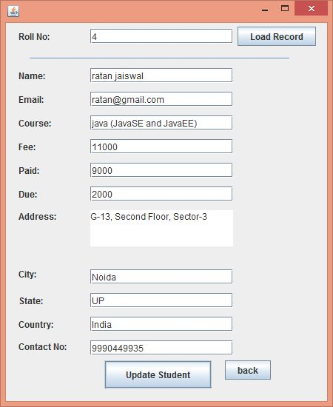
Update information and click on Update Student.
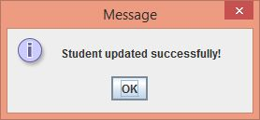
Click on ok button. Now View due fee.
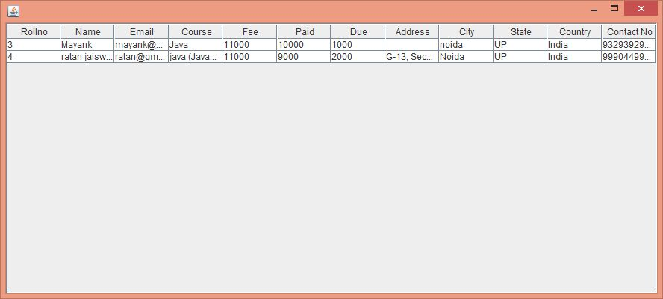
Now logout.

Thanks and Regards,
Sonoo Jaiswal.

